Kol Simcha Torah Gazette
For parshas vayera 5787
Vol 11 Issue 7 (Whole #518) Cheshvan 20 5787/October 31, 2026
Printed L’illuy nishmas Nechama bas R’ Noach, a”h
For a free subscription, please forward your request to keren18@juno.com
Past emails can be found on the website ShabbosStories.com under Brooklyn Torah Gazette
Will AI Take
Over the World?
By Rabbi Aron Moss

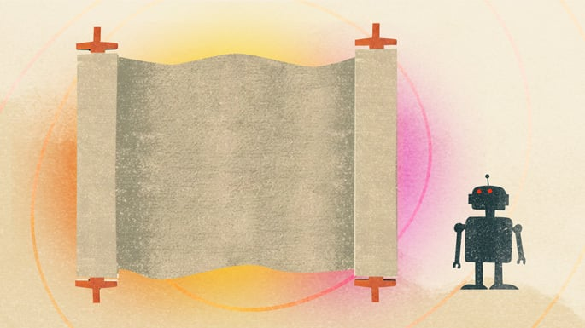
Art by Sefira Lightstone

Question: I'm getting a bit freaked out by this AI (Artificial Intelligence) revolution. It seems like it's going to take over everything. Surely the Torah has something to say about it. Could artificial intelligence bring about the end of the world?
Answer: The Torah has a much happier ending to the story of humanity. Not robots taking over the world, but the arrival of Moshiach, a time of peace, prosperity and spiritual enlightenment.
And yet, robots may play an important role in that time. The prophet Isaiah predicted, "Strangers shall stand and tend your flocks, and foreigners shall be your farmers and vineyard workers." Maybe those “foreigners” will turn out to be robots doing all the menial work while we get on with more important things.
But what if the robots don’t agree to being servants? What if they develop a mind of their own, become difficult to control, and threaten to destroy everything?
Well, it's happened before. The Torah tells us all about it. That's pretty much what the book of Genesis is about. And we are the robots.
G-d created human beings, gave us intelligence and free choice, and what happened? Adam and Eve disobeyed their very first instruction. Cain murdered his brother. Within ten generations, humanity had become so corrupt that the world needed a Flood. And not long after that, humankind united to build the Tower of Babel in an attempt to challenge heaven.
Sounds a bit familiar. A creator makes an intelligent being, gives it a degree of independence, and it rebels against its master.
The Torah doesn't just present the problem; it has solutions. Genesis offers three different responses to the misuse of intelligence and power.
The Flood. When a creation becomes destructive beyond repair, sometimes you have to shut it down and start again. Not everything we are capable of creating should be allowed to continue.
The Tower of Babel. When humanity united its powers for the wrong purpose, G-d divided them, muddled their languages, and scattered them across the earth. Sometimes the answer is not destruction but decentralization. Don't allow too much power to be concentrated in one place.
Abraham. This is the ideal. Rather than continually intervening to stop humanity from going wrong, G-d introduces us to a man who chooses to live according to a higher moral code, and who teaches that code to others. The ultimate solution is not to control intelligence from the outside, but to instill a moral compass that guides it from within.
These are three very relevant principles for the AI age. Know when to pull the plug. Don't concentrate unlimited power in one place. And above all, make sure our technological advances are guided by moral values.
The answers to our biggest questions, even in this robotic age, can still be found in a handwritten scroll given to us over three thousand years ago.
AI can do our laundry, and may even perform open-heart surgery one day. But it can't do morality for us. That is one responsibility we must never outsource.

Reprinted from the Chabad.Org website

The Unique Divine
Service of Isaac and the
Lessons for Jews Today
From the Teachings of the Lubavitcher Rebbe
Rabbi Menachem Mendel Schneerson, Zt”l
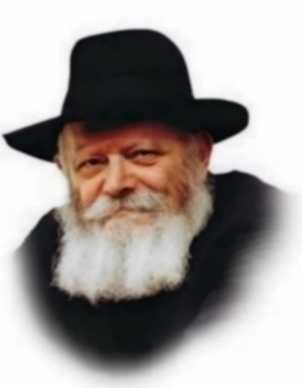
This week's Torah portion, Vayeira, introduces us to the second of our forefathers, Isaac. It also relates that Isaac was occupied with digging wells.
Abraham and Isaac achieved greatness by paving two distinct paths to spirituality. Abraham traveled from place to place, both within the borders of Israel and in other lands, and caused G-d's name to be known everywhere he went. Through his boundless hospitality, as well as through other means, he caused countless wayfarers to thank G-d for His bounty and goodness. Abraham's basic nature was kindness - giving and favorably influencing his fellow man.
Isaac, on the other hand, had a totally different approach. He never left the Holy Land and his basic nature was the personification of gevura (strength). Isaac's way of bringing holiness into the world involved elevating the lowly and bringing it closer to G-dliness; Abraham's method was to bring G-dliness down into the lower realms.
This path to spirituality is even apparent in Isaac's preoccupation with digging wells. A well is made when one digs and uncovers the water that was always there, albeit in an unrevealed state. Isaac did not bring the water to the well from an outside source; he merely removed the soil and rocks so that the water could flow forth on its own.
Whereas his father Abraham was primarily occupied with bringing holiness down into this world, Isaac spent his life uncovering the inherent holiness that already existed in the world. Isaac taught others that through their own efforts they could uncover the good and arrive at Divine truth.
From Abraham we learn how to elevate the physical world through studying Torah and performing mitzvot, causing the Divine light to descend and illuminate our surroundings. We also learn from him the obligation to spread the knowledge and appreciation of G-d through our own example and influence on others.
But this in itself is not enough. We must also learn from Isaac how to "dig wells" - how to uncover and reveal that spark of goodness and spirituality which exists within ourselves and every Jew. It is not sufficient to merely teach others about G-dliness; we must also know how to dig under the surface and reveal the "pintele Yid" - the inherent faith in G-d and spark of holiness - which is our birthright.
Even if a Jew seems to be nothing but "dust, clay and stones," that is, his Jewish spark seems to be dormant and hidden underground, we can learn from Isaac not be discouraged - this appearance is merely a camouflage. Under the lifeless surface lies a rich source of running water, of goodness, faith and love of G-d. All we have to do is remove the superficial layer of "clay" to reveal the pure Jewish soul within.
And what can we answer a Jew who cries, "But I've tried! I've dug and I've dug, and I can't seem to uncover my Jewish spark!" We must direct him to the example of Isaac, who persevered in his digging and was not discouraged, even when his wells were deliberately stopped up by his enemies, time and time again. For we are promised success if we, too, persevere and are relentless in our quest for G-dliness.

Reprinted from the 2003/5764 Parashat Vayeira edition of L’Chaim, a weekly publication of the Lubavitch Youth Organization

Rav Avigdor Miller on
The Stinging Bees

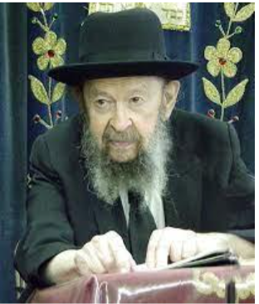

QUESTION: Why do bees sting?
ANSWER: It’s a great chessed. Bees are gizbarim of Hashem, they’re in charge of the honey. If anybody could come along and take the honey, there wouldn’t be any left for us. All the animals know that the bees sting. And therefore, they keep away from the honey. The sting of the bees is a miracle.
You know that when a bee stings it dies. It stings and leaves the sting in your body. And it flies away with at least part of its body open, and it dies. So, you can’t sting twice, it’s a miracle. A bee can’t sting twice. But it has to sting.
It’s like a man working in the street, and is working for the gas company. He takes off the lid and there is a hole in the ground. Watch Out! Men at work. He has to uncover that hole.
The bee is the men at work, it stings. He is at work for Hakadosh Baruch Hu, he is supposed to sting. Keep away from the bees, that’s all. You can’t blame the bee for stinging.

But the Queen Bee can sting and sting and remain alive. The Queen Bee can sting and sting and remain alive. Because the Queen Bee has to be able to protect herself more than the other bees. She is the one that makes all the babies, the Queen Bee. And she stings again and again, and doesn’t die.



You see the Yad Hashem. So now you know why bees sting, to learn the Chochmas Hashem in the Briyah. That’s one of the things that we say, Melo Chol Haaretz Kevodo.

Reprinted from a recent email of Toras Avigdor based on a question asked to Rav Avigdor Miller in March of 1999..

Thoughts that Count
For Our Parsha

"I will go down and see." (Gen. 18:21)
The great commentator Rashi explains that G-d descended to see the "end" of the deeds of the Sodomites. Although the people of Sodom did indeed sin, G-d looked, so to speak, to their last deeds; would they regret them and repent, or would they remain entrenched in their evil ways. (Sefer HaMaamarim)

"Take now your son, your only son, whom you love, Isaac" (Gen. 22:2)
G-d said to Abraham, "Take your son [to be sacrificed]."
Abraham said, "I have two sons, Isaac and Ishmael."
G-d said, "Your only son."
Said Abraham, "Each one is an only son to his mother."
G-d said, "Whom you love."
"I love both of them," replied Abraham.
"Take Isaac," G-d commanded. (Sanhedrin; Rashi)

And Abram rose up early in the morning (Gen. 22:3)
The fact that Abraham was willing to sacrifice his only son on the altar does not in itself adequately illustrate how dedicated he was to G-d. For did G-d, Himself, not speak to Abraham, saying, "Take your son, your only son"? Throughout the generations, there has been no scarcity of Jews willing to give up their lives to sanctify the Name of G-d even when G-d did not speak directly to them.
Rather, there is another merit and issue at stake in the fact that Abraham was willing to sacrifice his son, and that is the speed with which he hurried to fulfill the command. In fact, all of Abraham's deeds were done with a similar liveliness and alacrity, demonstrating his great joy and desire to fulfill G-d's will and bring pleasure to the Creator. This quickness to performing a mitzva, a trait of our forefather Abraham, stands as a merit for all of us until today. (Tanya)

Reprinted from the Parshat Vayera 5763/2003 (Issue #794) email of L’Chaim, a publication of the Lubavitch Youth Organization in Brooklyn, NY.

The Red Cross’s
Jewish Problem
By Doron Kornbluth

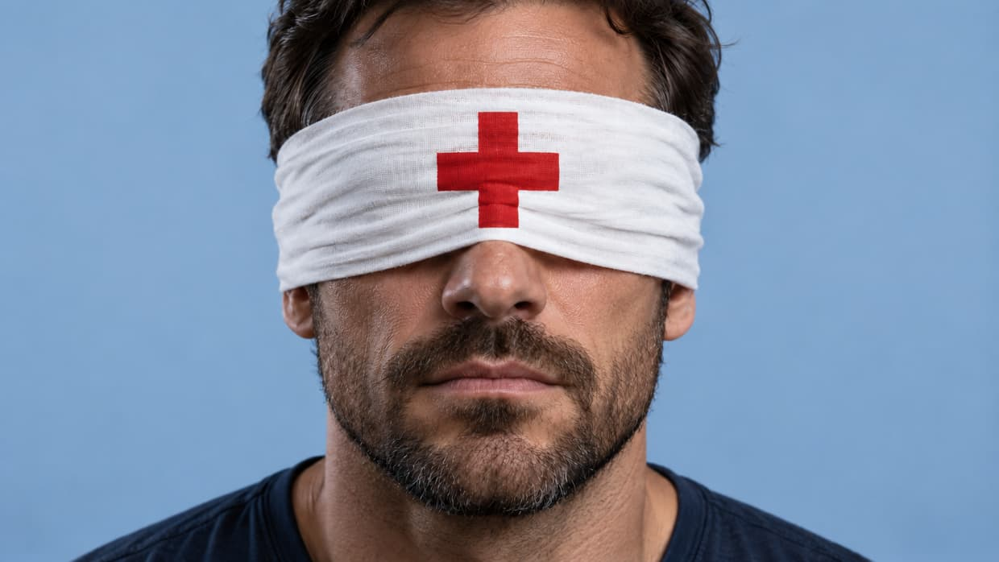
In 1944, the Red Cross toured a Nazi camp and wrote a glowing report. Last week, its president made a startling admission about the Israeli hostages in Gaza.

Two weeks ago, the head of the International Committee of the Red Cross (ICRC) acknowledged that the organization should have done more, earlier, to help secure the release of Israeli hostages held in Gaza. On October 10, 2026, the New York Times reported that Mirjana Spoljaric Egger, President of the ICRC, recently acknowledged in an interview that earlier pressure to release Israeli hostages from Gaza might have saved lives. Her exact words, as reproduced by The Times of Israel, were: “I personally think that pressure should have come earlier in the negotiations. We could have saved more lives.”
For me, the timing of her disclosure was eerie: I heard about it on the way to Theresienstadt, the notorious Nazi camp outside of Prague. Terezín (Theresienstadt) was different from the more (in)famous camps like Auschwitz or Treblinka: it wasn’t built as a death camp. Rather, it was a garrison town re-designed as a ghetto and transit camp. In the end, tens of thousands of Jews (and others) were imprisoned, starved, abused, and deported to their deaths elsewhere. Tens of thousands died in the camp itself. And it was the site of one of the most shameful episodes in the history of the International Red Cross.

The Show for the Inspectors
In June 1944, the Nazis invited a Red Cross delegation to inspect the camp. Before the visit, the Nazis transformed it into an elaborate propaganda set. Buildings were painted. Gardens were planted. Shops and cafés were prepared. Special activities were arranged. Thousands of Jews were deported to Auschwitz to reduce overcrowding. Those remaining were under strict orders – and supervision – to “play the part” assigned to them by the Nazis and their collaborators.
The Red Cross visitors "fell" for it, though their “mistake” was hardly innocent. They knew they were visiting a facility controlled by a murderous regime, yet they failed to investigate what was happening beyond the staged scenes, didn’t deviate one inch from the path the Nazis planned, and required no independent testimony from prisoners – though the ICRC's own historian, Daniel Palmieri, confirms that such interviews were normally a non-negotiable requirement of Red Cross inspections.
All this despite the fact that by the time of the visit, the Nazis had already deported approximately 70,000 Jews from Terezín, mostly to their deaths in camps farther east - and killed nearly 30,000 inside the camp itself. Indeed, during the visit, thousands of others were starving, abused and diseased, just “out of sight”.
The Red Cross failed to exercise the minimum of skepticism, independence, and moral courage that the situation demanded.
No surprise that the Nazis would try to pull off such a production. The problem was that the Red Cross failed to exercise the minimum of skepticism, independence, and moral courage that the situation demanded. Even worse, the ICRC produced a favorable report about the conditions at the camp – which would be used to strengthen Nazi rule.

Silence During, Escape After
Red Cross failures of that era went far beyond this one notorious visit. By 1942, the organization had received credible information about the systematic extermination of Europe's Jews, yet its leadership decided against publicly condemning the atrocities.
Red Cross travel documents were used by Nazi war criminals (including Mengele) to escape Europe.
After the war, another disturbing chapter emerged: Red Cross travel documents were used by Nazi war criminals (including Mengele, the notorious Auschwitz “doctor”) to escape Europe. The irony is painful: Despite warnings, the very organization that had failed so many innocent Jews during the Holocaust did almost nothing to prevent its documents being used by their persecutors to escape justice. The ICRC has subsequently acknowledged that its response to the Holocaust represented a grave failure. But its “Jewish Problem” continued after the war.

Shutting Out the Star of David
The Red Cross had long recognized the Red Crescent, used by Muslim-majority countries, and also the Red Lion and Sun, used by Iran. But when Israel's equivalent, Magen David Adom (the Red Star of David), sought recognition it was refused. This exclusion lasted for decades.
To her great credit, Dr. Bernadine Healy, president of the American Red Cross from 1999 to 2001, became a vocal advocate for ending the exclusion. Healy later maintained that her advocacy contributed to her departure from the American Red Cross. She also described an extraordinary exchange with ICRC president at the time, Cornelio Sommaruga, whom she accused of making an offensive comparison involving the Star of David and the swastika (he disputed her interpretation of his remarks.) Whatever he meant by the remark, the underlying discrimination was real.
Only in 2006, nearly six decades after Israel's establishment, was a compromise reached through the adoption of a new, neutral emblem known as the Red Crystal. Magen David Adom was finally admitted as a full member of the international movement, though without full equal use of its own symbol.

October 7 and the Hostages
Then came October 7, 2023. Hamas terrorists murdered approximately 1,200 people in Israel and abducted 251 hostages into Gaza, including children, the elderly, women, and men. Some were wounded, others required regular medication. Their families desperately sought help from the Red Cross. What did it do? Not much.
The question on everyone’s minds was: Could it have done more? Until last week, it wasn’t completely clear: The Red Cross does not possess an army. It cannot force Hamas to cooperate. On the other hand, it has diplomatic channels, international standing, and enormous moral authority - and didn’t seem to be using much (if any) of its clout to help Jewish hostages. Last week, the head of the organization admitted what many already suspected: it could have done more.

An 80-Year Pattern
The Red Cross is a valuable organization. It has helped – and is helping – countless innocents around the world. Over more than 160 years, it had built one of the most respected names in the world.

Which makes its “Jewish Problem” all the more disturbing: Though it has helped many Jews in many situations over the years, there is a clear and disturbing pattern stretching back over 80 years. In case after case, when it comes to helping Jews in need, the humanitarian organization does not try quite so hard. A great name – and great shame.

Reprinted from the aish.com website.
Shot Three Times at
Point-Blank Range:
“Only You Can Save Me”
By Michal Arieli
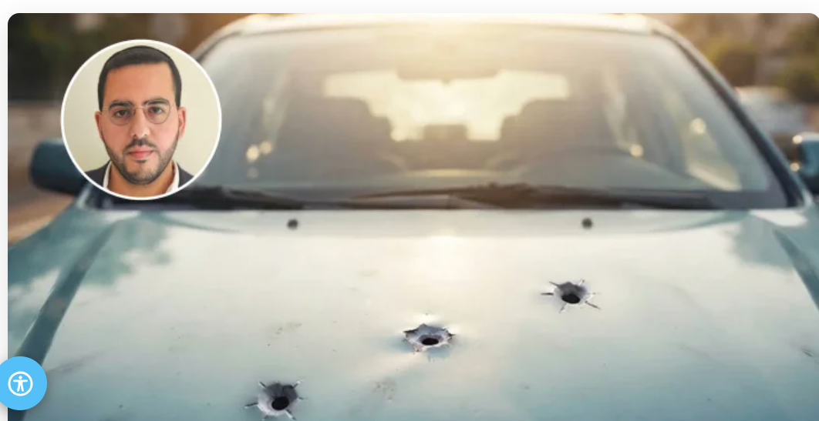
Pinchas Attia was shot at point-blank range in a case of mistaken identity. Lying wounded on the road, he turned to Hashem and began reciting Mizmor L’Todah.

Nothing could have prepared Pinchas Attia, a kollel student and father of two young daughters from Bnei Brak, for the morning when his completely ordinary life changed in seconds.
“Until that day, my life was completely routine,” he begins. “I learned in kollel for half the day, did some emotional therapy work, had certification as an NLP practitioner, devoted time to my family, and tried to help wherever I could. Everything was normal.”
The morning of the attack began that way too. It was the day after Lag BaOmer. Attia got ready to leave home, but his wife was delayed with their older daughter, so he went downstairs with their younger daughter and drove her to her caregiver.
“After I dropped her off, I returned to the car,” he recalls. “That’s when I discovered that something terrifying was waiting for me. Even now, when I think about it, I realize just how completely unexpected it was.”

Mistaken Identity
“I was approaching the front of the car when, out of the corner of my eye, I suddenly saw a figure dressed in black, wearing gloves and a helmet, pointing a gun at me,” Attia recalls.
What went through your mind at that moment?
“I don’t remember exactly. But because the car was still running, the dashboard camera recorded everything. You can see that my first instinct was to put my hands over my head and crouch beside the car. One bullet was fired and struck the vehicle. Then I lay down on the ground, and the attacker and another person approached from the side. They came within point-blank range and fired what, according to the assessment at Tel Hashomer, were another two or three bullets.
“In those seconds, I was literally begging Hashem to save me. I understood that He was the only One who knew the situation I was in. No one else knew what was happening or could possibly have imagined it.
“I’m not a complicated person, and I’m not involved in conflicts with anyone. I’m as far from that world as possible. Later, the police determined that I had been the victim of mistaken identity. They hurt me for no reason at all.”
After the attackers fled, Attia was left lying wounded on the road, crying out for help.
“The pain was terrible,” he says. “But the greatest miracle is that I am alive.”

“A Psalm of Thanksgiving”
Attia pauses before sharing another part of the story that remains especially meaningful to him. In the period before the shooting, he had been regularly studying She’arav B’Todah by Rabbi Shalom Arush, a book centered on gratitude and recognizing Hashem’s presence even during difficult circumstances.
“I felt the book was changing my outlook on life,” he says. “And that affected me even in the moments after I was wounded. It may sound unbelievable, but after the attackers left, the first thing I did was recite Mizmor L’Todah, ‘A Psalm of Thanksgiving.’
“I’m not sure I was on the level of reciting it from a place of gratitude,” he adds. “But Rabbi Arush explains that there is also an idea of recognizing that Hashem is behind what happens to us. When I realized I was still alive, that was the feeling that filled me.”
After reciting the psalm, Attia began speaking directly to Hashem. “I said, ‘Only You can save me. I have a wife and two little girls. They need me. Watch over me.’”
The physical pain was overwhelming, but he remained conscious and managed to call loudly enough for help. Passersby contacted emergency services, and Attia handed his phone to a woman nearby and asked her to call his wife.
What was your wife going through at that time?
“She had just dropped our daughter off at daycare and had stayed there for a little while. When she saw my phone calling, she answered and said, ‘I’ll call you back,’ without realizing that it wasn’t me speaking. They called again, and again she said she would call back. Only on the third attempt did she really hear what they were saying.
“They told her I had been injured. She asked, ‘What do you mean injured? Was he in an accident?’ And then they told her, ‘He was shot.’
“My wife managed to arrive before the ambulance. Amid all the pain and confusion, I held out the car keys to her and said, ‘I don’t know why they shot me, but in the meantime, please lock the car.’ Somehow, Hashem helped me keep my composure.
“After that, they evacuated me to Tel Hashomer. The pain was on a level I can’t describe. The body is screaming for help, while at the same time the soul feels like it is fighting not to break.”

“Remember Us for Life”
When Attia arrived at the hospital, a team of specialist doctors was waiting for him. Within minutes, he was sedated and taken into an operation that lasted eight and a half hours. Meanwhile, his family was only beginning to comprehend what had happened.
“Everyone was in complete shock,” he says. “They couldn’t stop crying and praying.”
His next clear memory is waking in the recovery room and seeing his wife. Despite being connected to tubes and medical equipment, he was alert from the moment he woke up.
“That reassured my wife tremendously, because she had also gone through a trauma,” he says. “Then more family members came in. Even though I was connected to all kinds of machines and tubes, I threw in a few jokes, which helped lighten the atmosphere a little.”
How did the doctors describe your condition?
“I understood from them that I had arrived at the hospital in serious condition and that there was a significant risk of injuries that could affect my future. I also have to say that I received incredibly professional and devoted care throughout.”
The road back was long. Attia remained hospitalized for approximately a month, underwent another operation, and for a period could barely get out of bed.
“I went from being a healthy, independent person to being completely dependent on other people,” he says. “I saw with my own eyes how everything can change in a single moment.”
After approximately a month, he was discharged to continue recovering at home. Slowly, his condition improved. Four and a half months after the shooting, Attia says he had largely returned to the life he had before.
“I still live in the same building. I take my daughters to their programs every morning. I learn in kollel as usual, and I drive the same car in which I was injured. To this day, there is still a hole in the hood from the bullet that struck it.”
Honestly, don’t you feel afraid?
“There are moments when I get frightened and think that maybe someone could, G-d forbid, hurt me,” he admits. “But I don’t let fear paralyze me. I truly believe that our entire lives are an enormous kindness from the Creator of the world, and if I am in His hands, I have nothing to fear.
“Chovot HaLevavot teaches that no person can independently benefit or harm another person. I deliberately returned to my routine because I know that this is the best way for me to continue living and giving thanks.”
Did you hold a thanksgiving celebration?
“Of course. I held a large seudat hoda’ah with the goal of sanctifying Hashem’s name. After being shot at point-blank range and having my life saved, I feel that Hashem did not leave me in this world for no reason. I have a responsibility to sanctify His name.
“On a personal level, I also feel that I have changed. Suddenly, all of life looks different. When I say in the High Holiday prayers Zochreinu L’Chaim, ‘Remember us for life,’ and Av HaRachamim, ‘Father of mercy,’ the request is real and tangible now.
“In previous years, my prayers often focused on things that now seem much less important, like a bigger apartment, a better job, upgrades and bonuses. This year, after what happened, I say Zochreinu L’Chaim and stop there.
“I feel that life itself is such an enormous request. It cannot be taken for granted. Only after asking for that basic gift do I allow myself to continue and ask for anything else.”
Months after the attack, Attia is back in the ordinary life he once barely thought about: taking his daughters out in the morning, learning in kollel, driving his car, and returning home to his family.
The routine looks much the same. To him, it no longer feels ordinary at all.
Reprinted from the Hidabroot.com website.

